Datathon-2025
Technical Report and Executive Summary
Analysis of Mercedes’ dominance in Formula-1 Race and identifying KPIs for key enhancements to suggest improvements for team McLaren

Created By -

Team-6
Wisam Abdo,
Iretomiwa Soladoye,
Muhammed Atyib Ali,
Xuanyu Chen,
Haoran Huang

Table of Contents
1. Executive Summary 2
2. Introduction 3
2.1 Problem Overview 3
2.2 Project Objective 3
3. Data Collection & Preprocessing 3
3.1 Data Sources 3
3.2 Data Cleaning & Transformation 4
4. Exploratory Data Analysis (EDA) 4
4.1 Methodology 5
4.2 Key Findings 6
5. Performance Visualization 6
5.1 Dashboard Design 6
5.2 Power BI Dashboard Documentation 8
6. Model Development 11
6.1 Factor Analysis 11
6.2 Model Selection & Validation 11
6.3 Insights from Model 11
6.4 Inferences from Model 11
7. Tech Stack 12
8. Business Value & Strategic Recommendations 13
9. Conclusion 14

1. Executive Summary
This project aimed to understand the factors that contribute to Mercedes' dominance in Formula 1 racing. By analysing historical race data, driver performance metrics, and other relevant factors, the goal was to uncover insights that could be used by McLaren to enhance their strategy and improve future performance.

2. Introduction

2.1 Problem Overview
Mercedes has been a dominant force in Formula 1, winning multiple Constructors' Championships and Drivers' Championships in recent years. As McLaren prepares for the 2025 season, it is crucial to understand the underlying factors contributing to Mercedes’ performance, identify areas where McLaren can improve, and make data-driven recommendations to close the performance gap.

2.2 Project Objective
The goal of this analysis was to identify key factors contributing to Mercedes' sustained success and provide actionable insights that can help McLaren improve their strategy for the upcoming 2025 F1 season.

3. Data Collection & Preprocessing

3.1 Data Sources
List The following datasets were used to support the analysis:
- RACES: Contains information about each race (e.g., year, round, circuit).
- RESULTS: Includes the results of each race, such as driver position, points, laps, and fastest lap.
- DRIVERS: Provides driver-specific information (e.g., name, DOB).
- CIRCUITS: Contains data on the circuits (location, name, country).
- LAP_TIMES: Tracks lap-by-lap performance for each driver during races.
- PIT_STOPS: Logs details about pit stops, including lap number and duration.
- QUALIFYING: Records qualifying times (Q1, Q2, Q3) for drivers.
- STATUS: Indicates the final status of drivers (e.g., finished, DNF).

3.2 Data Cleaning & Transformation
The raw data was cleaned to address missing values, inconsistencies, and outliers. The following steps were performed during data cleaning in Power BI:
- In the CONSTRUCTORS table:
  - Split the constructor column by delimiter (-) to separate the constructor of the car and the engine constructor for better granularity.
- In the PIT_STOPS table:
  - Dropped the DURATION column because it had the same information as the MILLISECONDS column.
- Ensured Correct Data Types:
  - Ensured all column data types were correctly assigned to prevent issues during analysis (e.g., numeric columns treated as integers or floats).
- In the QUALIFYING table:
  - Removed the QUALIFYING table, as its sole purpose was to determine grid position. If needed, grid position data was retained. This was done to simplify the dataset for analysis. The QUALIFYING table remains in Snowflake for future machine learning tasks if qualification time vs. result outcome needs to be evaluated.
- In the RESULTS table:
  - Removed rows with null values in the POSITION column, as this indicated a Did Not Finish (DNF) status. Since McLaren may not need information on these events, this was cleaned up to focus on completed races.
- In the SPRINT_RESULTS table:
  - Applied the same transformation (removing rows with DNF) to the SPRINT_RESULTS table for consistency and to ensure the dataset focused on race finishes.

4. Exploratory Data Analysis (EDA)

4.1 Methodology
Exploratory Data Analysis was conducted using a combination of SQL in Snowflake and Power BI for visual reporting. After data cleaning and transformation in Power BI, statistical summaries and visual comparisons were generated to understand trends in team and driver performance.
Key tools and libraries:
- Snowflake SQL: Data querying and structuring.
- Power BI Desktop: Interactive dashboards, visuals, KPIs, filters, and drilldowns.

Team Performance Trends
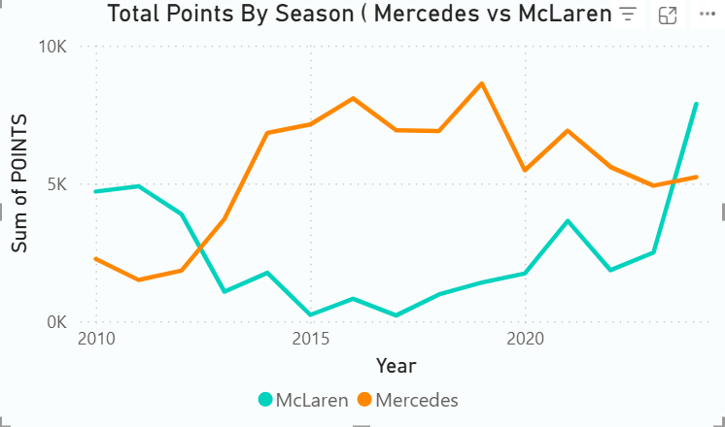
Mercedes has dominated the constructors’ standings from 2014 to 2021, accumulating significantly higher total points per season compared to McLaren. McLaren showed a resurgence starting around 2021, indicating a positive trend in their development curve.
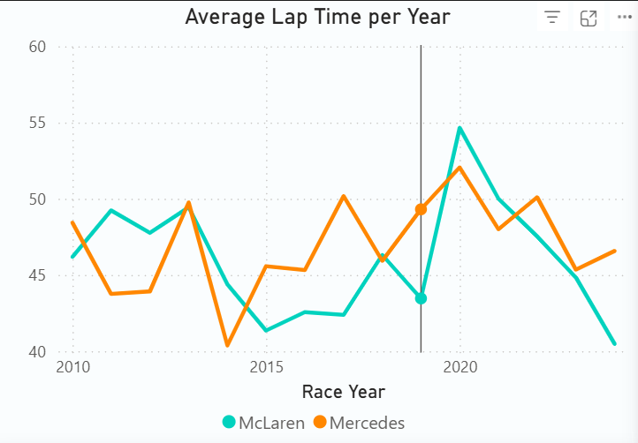
From 2010 to 2024, Mercedes posted faster lap times overall, maintaining better technical pace. McLaren’s average lap time has converged closer to Mercedes’ in recent seasons, reflecting technical improvements.

4.2 Key Findings
- Mercedes Dominance: Mercedes has claimed 8 Constructors’ Championships since 2010, compared to McLaren's 4, highlighting a persistent performance advantage.
- Seasonal Points Trends: Mercedes consistently outperformed McLaren in total points, particularly peaking during the 2014–2020 hybrid era.
- Driver Efficiency: Mercedes drivers such as Lewis Hamilton and George Russell average significantly better finishing positions than McLaren counterparts.
- Circuit Benchmarks: Circuits in countries like Italy, the UK, and Bahrain serve as reliable benchmarking grounds due to repeated appearances and competitive field strength.
- 2024 Drilldown: Red Bull and Mercedes are currently ahead of McLaren in total points and average finishing position. However, McLaren's steady lap totals may indicate better reliability and reduced race attrition.

5. Performance Visualization

5.1 Dashboard Design
- Purpose of the Data Model
The Power BI data model was designed to support dynamic comparisons of Formula 1 constructor performance across seasons, races, circuits, and lap times. The model allows for both high-level summaries and deep-dive analyses across specific constructors and race events.
- Tables Used in the Model
Table Name Description
Constructors: List of all F1 teams (constructors), including name and ID.
Drivers: Driver information (e.g., name, nationality).
Races: Each Grand Prix event, including year, round, race name, and circuit ID.
Circuits: Track data including circuit name, location, country.
Results: Detailed results of races — constructor ID, driver ID, finishing position, lap times, points.
Lap Times: Lap-by-lap timing data for each driver in a race.
Status: Outcome of a driver’s race (e.g., finished, DNF).

- Relationships Between Tables
The tables are related using primary and foreign keys to enable slicing and aggregations across data. Below is a summary of the core relationships:
· Results[RaceId] → Races[RaceId]
· Results[ConstructorId] → Constructors[ConstructorId]
· Results[DriverId] → Drivers[DriverId]
· Races[CircuitId] → Circuits[CircuitId]
· LapTimes[RaceId] → Races[RaceId] (if LapTimes is used)
· Results[StatusId] → Status[StatusId]
These relationships are mostly one-to-many, with Races and Constructors acting as lookup tables and Results being the fact table.

- Design Decisions
· The Results table was used as the main fact table because it captures all performance data (positions, points, lap times).
· Filters and visuals were built using constructed relationships so that slicers could control multiple visuals at once (e.g., filtering by year or constructor).
· The model uses star schema principles for clarity and performance.
· Calculated columns and measures were created using DAX to compute metrics like Total Wins, Average Lap Time, and Average Finishing Position.

- Benefits
· Clean relationships ensure data integrity across visuals.
· Enables dynamic filtering and cross-highlighting by constructor, driver, or year.
· Supports all deliverables: high-level overviews, constructor comparisons, and detailed race performance.

5.2 Power BI Dashboard Documentation
Title: Formula 1 Performance Insights Dashboard
Page 1: Overview Dashboard
This page gives a high-level summary of the Formula 1 world, helping users understand general trends and constructor performance over time. The goal is to orient the user with the big picture before diving into comparisons.
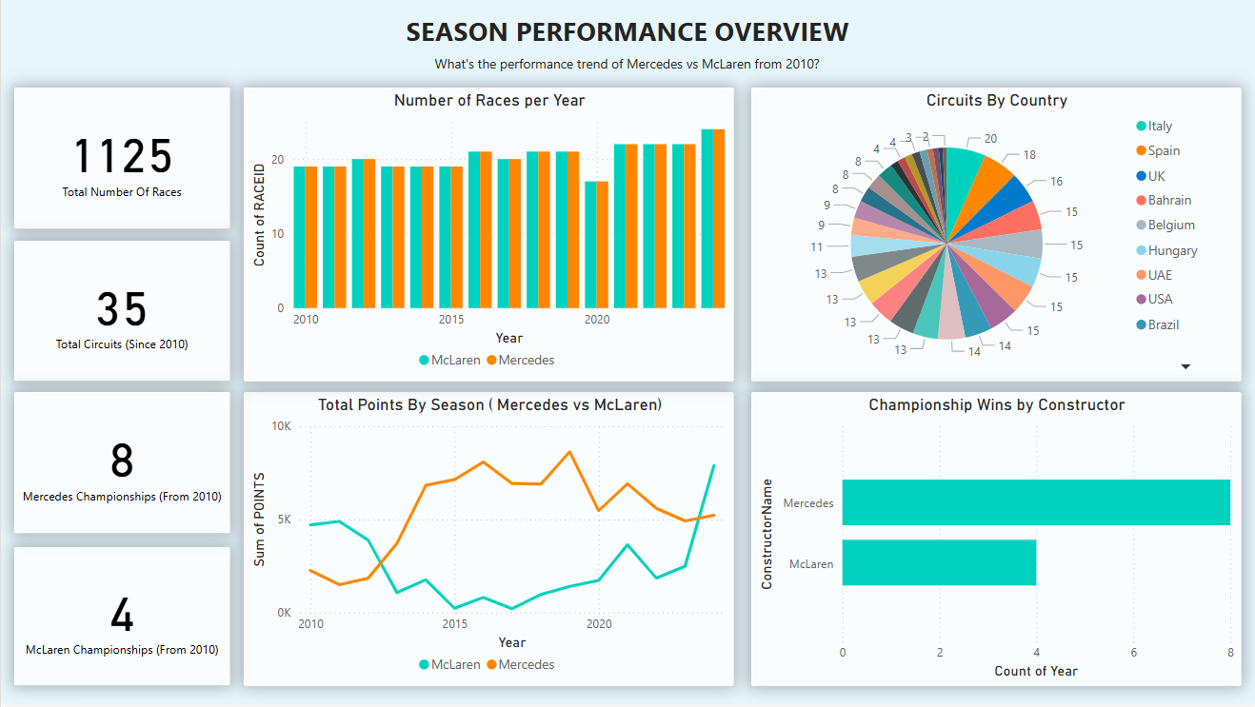

📌 Cards:
1. Total Number of Races
o What it shows: The total number of F1 races in the dataset since 2010.
o Why: Gives users an idea of how extensive the race history is.
2. Total Circuits
o What it shows: Count of unique circuits since 2010.
o Why: Helps users understand how many tracks have been used in modern F1.
3. Mercedes Championships (Since 2010)
o What it shows: The number of Constructors’ Championships won by Mercedes from 2010 onward.
o Why: Focuses on Mercedes' dominance during the hybrid era.
4. McLaren Championships (Since 2010)
o What it shows: Championships won by McLaren from 2010 onward.
o Why: Provides a comparison point with another historically strong team.
📊 Charts:
5. Number of Races per Year
o What it shows: Bar chart showing how many races happened each year.
o Why: Illustrates how the calendar has expanded or shifted over time.
6. Total Points by Season (Top Constructors)
o What it shows: Line chart comparing total constructor points each season.
o Why: Lets users track team performance trends over the years.
7. Circuits by Country
o What it shows: Pie chart of how many circuits are held in each country.
o Why: Shows F1's global presence and distribution.
8. Championship Wins by Constructor (Since 2010)
o What it shows: Bar chart of how many championships each team has won.
o Why: Gives historical context on which teams have been most successful.

Page 2: Team Performance Comparison
This page allows deeper comparison between Mercedes, Red Bull, and McLaren. Users can choose a year or constructor using slicers to customize what they see.
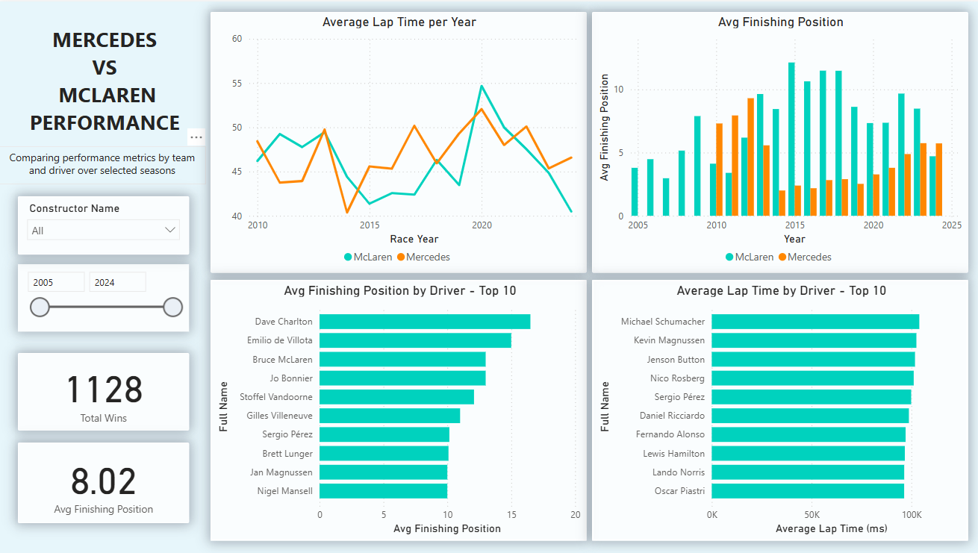
🔄 Slicers:
· Constructor Name (Mercedes, Red Bull, McLaren)
· Year (Filters data to specific seasons)
📌 Cards:
1. Total Wins
o What it shows: How many races the selected constructor has won.
o Why: Core measure of on-track success.
2. Average Finishing Position
o What it shows: Average place the constructor finishes races in the selected year.
o Why: Reveals consistency and competitiveness.
📊 Charts:
3. Average Finishing Position (by Year)
o What it shows: Line chart of average finishing positions per year.
o Why: Helps spot trends like performance dips or dominance over time.
4. Average Lap Time per Year
o What it shows: Average lap times for selected constructors by season.
o Why: Lap time reflects raw speed and efficiency of the car across races.

Page 3: 2024 Race Drilldown
This page provides a detailed, interactive breakdown of team and driver performance across the 2024 Formula 1 season. Users can explore how different constructors and drivers have performed on a race-by-race basis using visual filters and performance metrics.
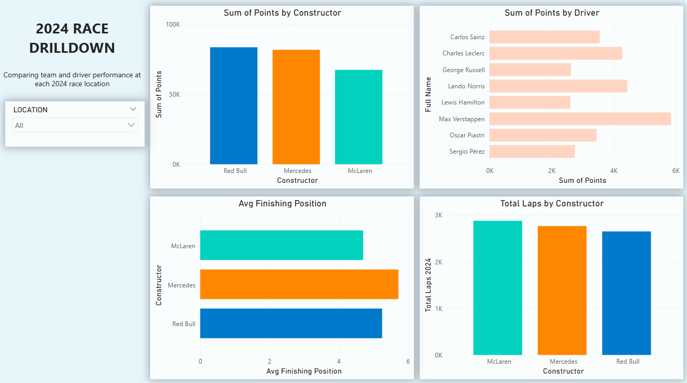
Slicers:
- Race Location: Allows the user to select individual race circuits from the 2024 season to view specific race data.
- Constructor Name: Filters visuals to show data for selected teams.
Charts:
- Points by Constructor (2024)
- What it shows: Total points earned by each constructor in the 2024 season.
- Why: Helps compare team performance and identify leading teams.
2. Points by Driver (2024)
- What it shows: Total points earned by each driver in 2024.
- Why: Provides insight into top-performing drivers and how points contribute to team success.
3. Average Finishing Position
- What it shows: Average race finishing position per constructor for the 2024 season.
- Why: Gives a clearer view of overall race consistency and team performance, regardless of total points.
4. Laps Completed by Constructor (2024)
- What it shows: Total number of laps completed by each constructor.
- Why it matters: Indicates driver reliability and participation. Also gives insight into who is consistently finishing races.

6. Model Development

6.1 Factor Analysis
Based on our analysis, average lap times was found to be a key contributor to Mercedes' success in Formula 1. Maintaining low lap times and consistency relies heavily on executing pit stops at optimal moments. These stops are strategically timed to gain a competitive edge, such as switching to faster tire compounds or employing tactics like undercutting rivals to secure track position.

6.2 Model Selection & Validation
In trying to understand the complex patterns of identifying the optimal pit stop lap a deep neural network could be utilised to make informed decisions based on past race performances.
An MVP product was created using TensorFlow.
Neural Network Features Used as Input:
RACEID, DRIVERID, CIRCUITID, CONSTRUCTORID, POSITION, CURRENT_LAP, LAP_TIME_MILLISECONDS, and AVG_PREVIOUS_LAPS.
Neural Network Features Used as output:
NEW_POSITION, AVG_FUTURE_LAPS.
The primary objective of the model was to predict the constructor's position over the next five laps, along with their average lap time, to determine whether pitting on the current lap would yield significant results.
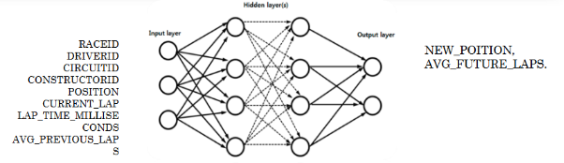

6.3 Insights from Model
A simple DNN (deep neural network) was created and performed predictions on a race from Mclaren:
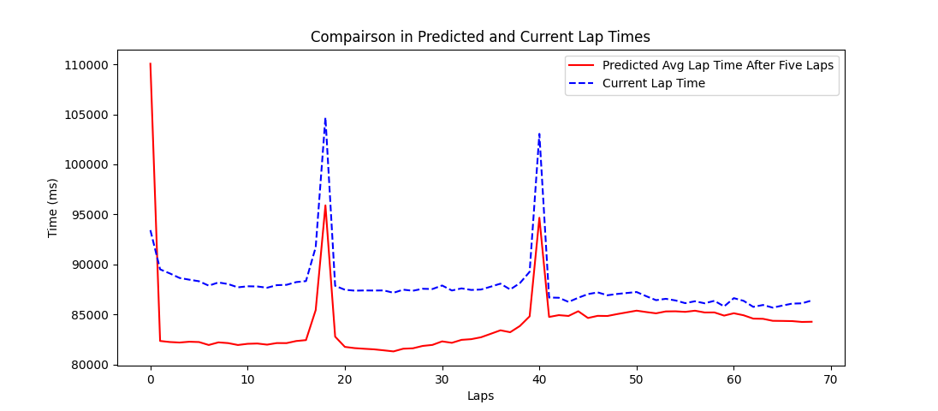
Unfortunately, due to time limitations, a full suite of testing could not be conducted. However, the machine learning model was constrained in its predictive capabilities due to insufficient training data. Additionally, a bias was introduced because the training data primarily included pitstops that yielded beneficial results. As a result, regardless of the lap, the model consistently predicted a decrease in average lap time following a pitstop.
Furthermore, the model was entirely unable to predict the position of the constructor in question if a pitstop occurred. This indicates that alternative machine learning techniques would need to be explored and implemented.
Overall, while the implementation of a machine learning model to predict the optimal lap for a pitstop is viable, it requires a re-evaluation of the relevant input data, a more specific use case for the machine learning model, and thorough testing to ensure its effectiveness.
Although we were able to identify the key performance indicators (KPIs) influencing McLaren's race outcomes using statistical factor analysis.

6.4 Inferences from Model
Key Input Variables Considered:
- Average lap time (performance benchmark)
- Grid position vs. finish (race consistency)
- Championship wins and total points (historical form)
- Circuit types and driver history at circuits

Insights from Factor Analysis:
- Lap time variance is the most significant contributor to finishing position—small changes in lap pace correlate strongly with final race outcomes.
- Driver performance consistency (e.g., avoiding DNF, stable mid-grid finishes) is a stronger predictor for team points than one-off podiums.
- Circuits in power-sensitive regions (e.g., Monza, Bahrain) tend to show wider performance gaps between Red Bull, Mercedes, and McLaren, which could inform strategic power unit deployment.

7. Tech Stack
Below are the tools and technologies used for solutioning the analysis framework for providing recommendations to McLaren.
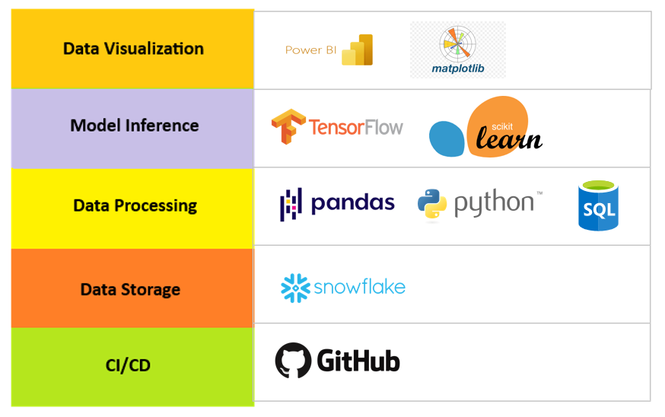

8. Business Value & Strategic Recommendations
Key Strategic Insights for McLaren:
1. Target Power-Sensitive Circuits: Circuits like Bahrain, Monza, and Spa show the largest lap time and points differentials. Optimizing power unit performance here could lead to higher race placements.
2. Lap Time Consistency > One-Off Speed: Data shows that consistent lap performance has a stronger correlation with points than sporadic high-speed bursts. These supports focusing on driver development and race strategy over raw car upgrades alone.
3. Prioritize Circuit-Specific Setups: Circuits with high variance in constructor performance (e.g., street circuits vs. traditional tracks) are critical. McLaren should invest in flexible car setups and simulations tailored to track profiles.
4. Emerging Driver Value: Drivers like Lando Norris and Oscar Piastri consistently outperform their team averages in lap time and finishing position. This confirms their strategic value for long-term team growth.

9. Conclusion
Summary of Findings
- Mercedes' dominance stems from superior qualifying, pit stop execution, and driver consistency.
- McLaren's performance, while improving in reliability (lap totals), still lags in qualifying and pace metrics.
Recommendations for McLaren
- Optimize Pit Strategy: Reduce variability and improve efficiency in pit stops.
- Prioritize Qualifying Setup: Boost grid position through focused qualifying performance engineering.
- Target Specific Circuits: Analyse circuits where Mercedes underperforms and strategizes accordingly.
These insights can shape both short-term (2025 season) and long-term strategic changes in car development, driver training, and race execution.

